**Steps to create a git repository: -**

**Step 1)** Go to github.com



2) Create an account on GitHub if you don’t have an account. Sign in if you already have an account.

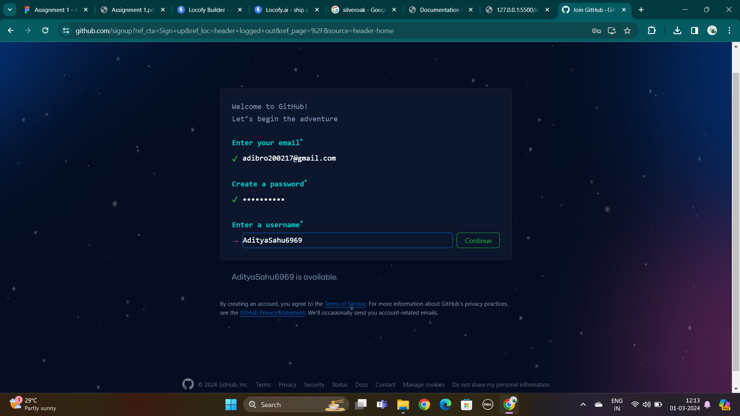

3) You will see the page below after signing in.

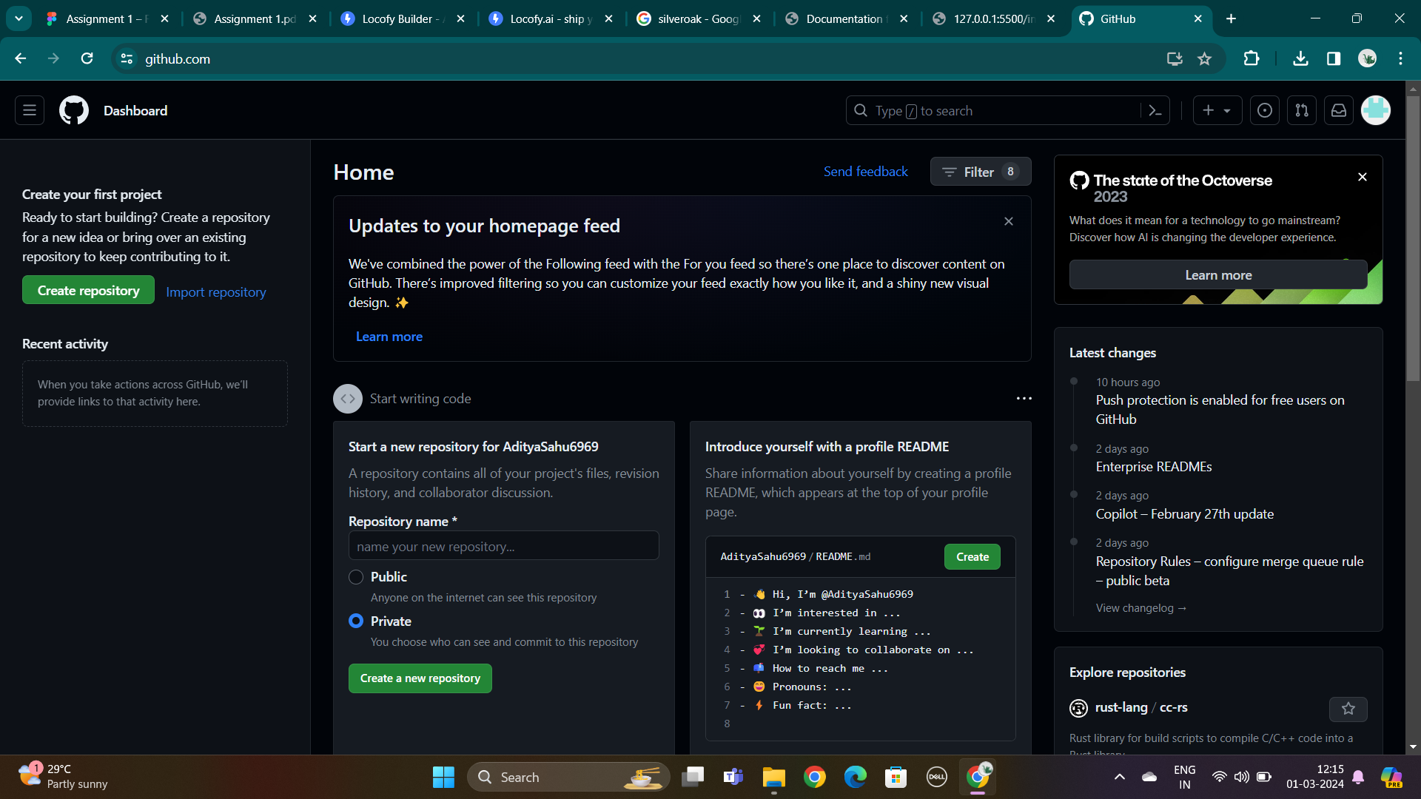

4) Go to plus icon on the top right side and create a new repository.

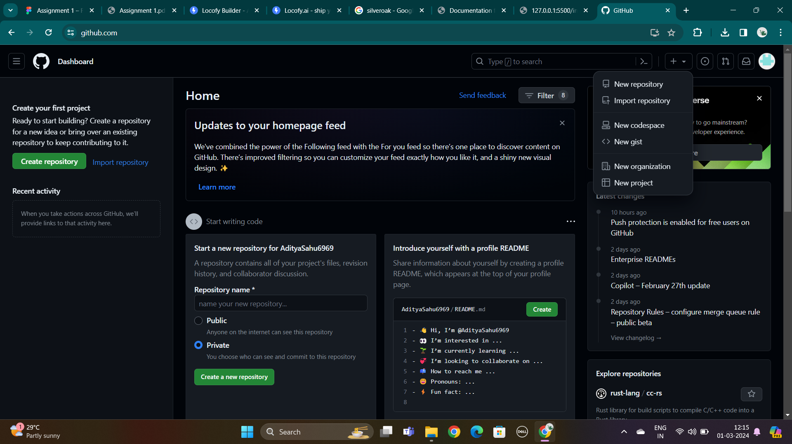

5) Give name to your new repository.

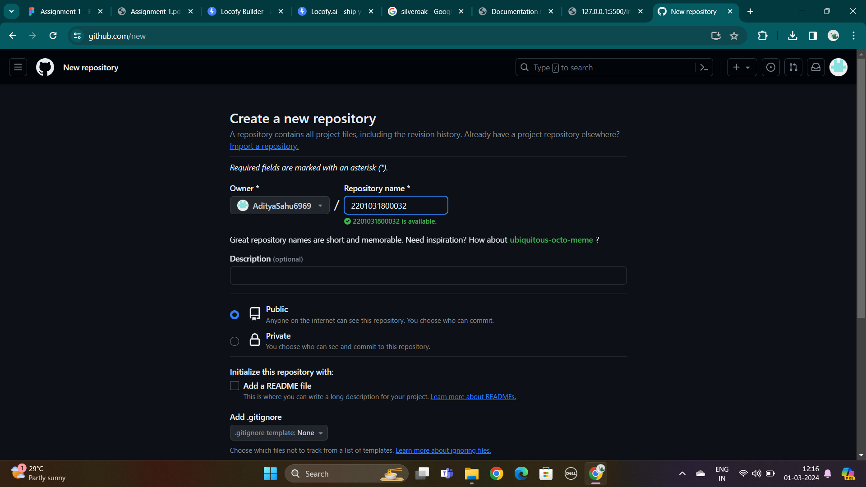

6) Click on create repository.

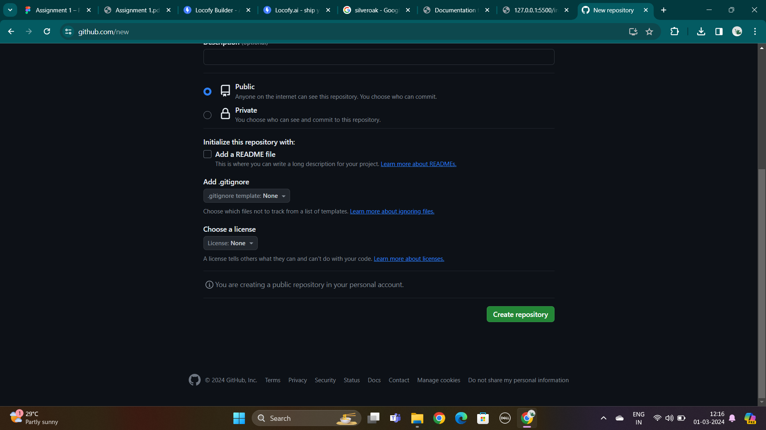

7) You have finally created a new repository.

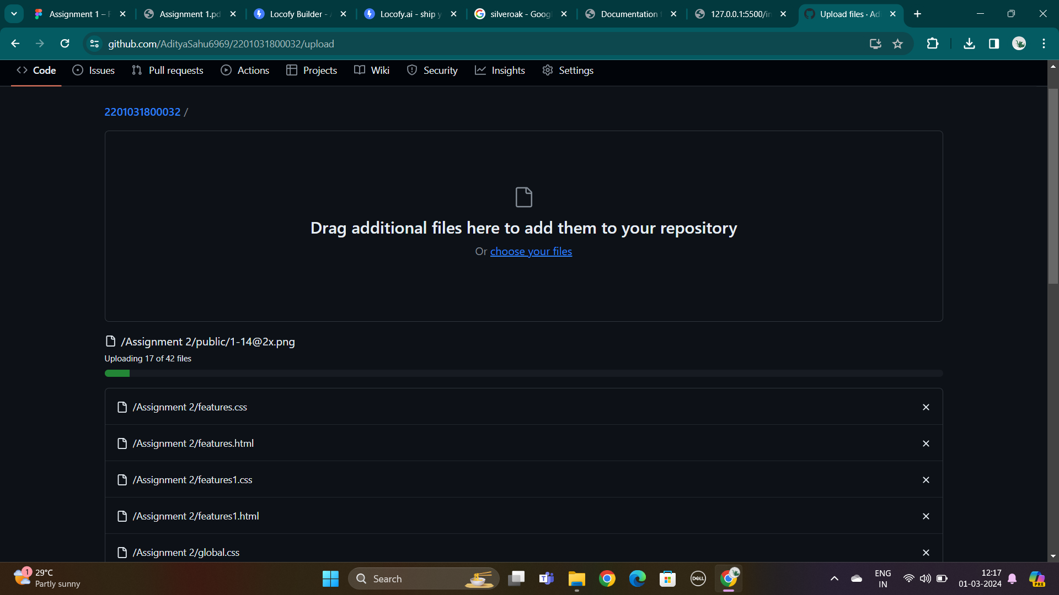

8) click on add-file to add your assignment file.

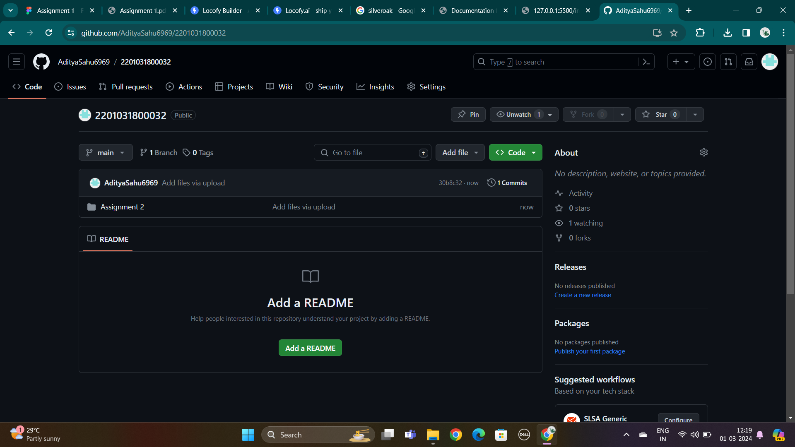

9) Click on upload files to upload your files from your computer.